VISVESVARAYA TECHNOLOGICAL UNIVERSITY
Jnana Sangama, Santhibastawad Road, Machhe

Belagavi - 590018, Karnataka, India


FILE STRUCTURES LABORATORY WITH MINI PROJECT

“Event Management System”

Submitted in the partial fulfilment of the requirements for completion of the 6th semester File Structures laboratory with Mini Project [15ISL68] for course of

BACHELOR OF ENGINEERING
IN

INFORMATION SCIENCE AND ENGINEERING

For the Academic Year 2018-2019

Submitted by

SYEDA ZOYA KULSUM 1JS16IS082
SURAJ KOTECHA 1JS16IS080

Under the Guidance of

Mrs. Sahana V

Asst. Professor, Dept. of ISE, JSSATEB
Mrs. Sudha P R
Asst. Professor, Dept of ISE, JSSATEB


2018-2019

DEPARTMENT OF INFORMATION SCIENCE AND ENGINEERING

JSS ACADEMY OF TECHNICAL EDUCATION

JSS Campus, Dr.Vishnuvardhan Road, Bengaluru-560060

JSS MAHAVIDYAPEETHA, MYSURU

JSS ACADEMY OF TECHNICAL EDUCATION
JSS Campus, Dr.Vishnuvardhan Road, Bengaluru-560060

DEPARTMENT OF INFORMATION SCIENCE & ENGINEERING


CERTIFICATE

This is to certify that File Structures mini-project entitled “Event Management System” has been successfully completed by Syeda Zoya Kulsum [1JS16IS082], Suraj Kotecha [1JS16IS080] of Ⅵ semester Information Science and Engineering from JSS Academy of Technical Education under Visvesvaraya Technological University Belagavi during the year 2018-2019.

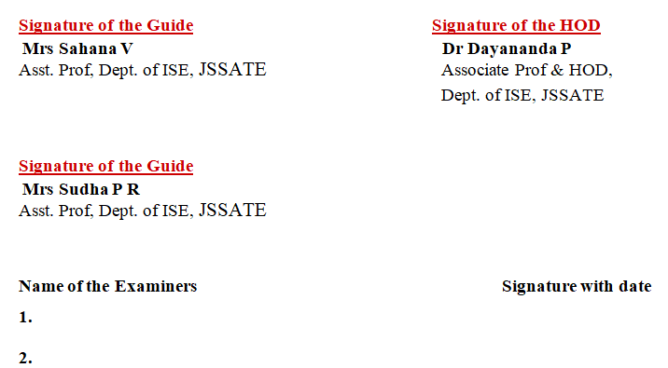

ACKNOWLEDGEMENT

The satisfaction and euphoria that accompany the successful completion of any task would be incomplete without the mention of the people who made it possible. So with gratitude, we acknowledge all those whose guidance and encouragement crowned my effort with success.
First and foremost, we would like to express our sincere gratitude to His Holiness Jagadguru Sri Sri Shivarathri Deshikendra Mahaswamiji for his divine blessings, without which the work wouldn’t have been possible.
We would like to thank Dr. Mruthyunjaya V Latte, Principal, JSSATE, Bengaluru for his constant encouragement.

We express our sincere gratitude for our beloved Head of the department, Dr Dayananda P, for his co-operation and encouragement at all the moments of our approach.

We would like to express our gratitude to Mrs Sahana V, Asst. Professor, Dept. of ISE, JSSATE, Bengaluru for her guidance and assistance.
We would like to express my gratitude to Mrs Sudha P R, Asst. Professor,Dept. of ISE, JSSATE, Bengaluru for her guidance and assistance.

We would like to thank all our ISE department teaching staff and non-teaching staff for providing us with their valuable guidance and for being there at all stages of our work.

Syeda Zoya Kulsum [1JS16IS082]
Suraj Kotecha [1JS16IS080]

ABSTRACT
This project is done to demonstrate the working of file system using file structures at application level. The name of the project is Event Management System, implemented in C++.
The execution of the system first displays a home page for either entering information or viewing already existing system. There are options to enter events, sponsors, clients, employees, ad agencies, participants and their details, all related through their respective event ids.
There is option for committing the changes/new entries made in the system to prevent loss of records/data upon system failure/crash. Rollback option gives the users the alternative to go back to the previous state of the system. The changes if not committed can be rolled back.
The view information option is to view existing event details, sponsor details, client details and so on. It also has options for analysing marketing and comparing the profits/losses of the events.
The file concept used combines parts from both hashing and indexing concepts to create a modified version, which mainly works on offsets.
In this method, we add an index line to the beginning of each file.
The format of the index line is as follows:

e1:o1|e2:o2|e3:o3|

{e1,e2,e3,....} - Event ids
{o1,o2,o3,....} - Corresponding offsets

This method saves space by using same file for indexing and provides direct access to records.
CONTENTS

Introduction 2
Vision 2
Scope 2
Aim and Objectives………………………………………………………………………………………………………………………..3
Literature Survey 4
File Structures 4
Opening a file 4
Writing/Reading a file 5
Closing a file 5
File Structure concept 6
System Requirements 9
Software Requirements 9
Hardware Requirements 9
System Design and Implementation 10
Add Records 10
Display Records 12
Modify Records 13
Search Records 15
Source Code 15
Snapshots 21
Enter Data 22
New Event 22
New Employee 23
New Client 24
New Vendor 25
New Sponsor 26
New Ad Agency 26
Participant Details 26
Commit 26
Rollback 27
View Event Information 27
Conclusion 30
References 31

